./

Learning Report – Applied System Development Life Cycle and Software Testing



|  |  |  |  |  |  |
| --- | --- | --- | --- | --- | --- |
| **Ver. Rel. No.** | **Release Date** | **Prepared. By** | **Reviewed By** | **To be approved By** | **Remarks/Revision Details** |
| 1 |  | Name/PS No | Name/PS No | Module Owner Name | Comments |
| 2 | 15/02/21 | Kumar Utsav/99003774 |  |  |  |
| 3 |  |  |  |  |  |
|  |  |  |  |  |  |
|  |  |  |  |  |  |

**Document History**

Table of Contents

Table of Figures 3

Table of Tables 4

ACTIVITY 1: SYSTEM/ SOFTWARE DEVELOPMENT 4

**INTRODUCTION** 4

**MY PRODUCT: “Name ”** 6

**SWOT ANALYSIS** 7

**REQUIREMENTS** 7

**DESIGN** 8

HIGH LEVEL DESIGN 8

LOW LEVEL DESIGN 11

**TEST PLANS** 13

**REFERENCES** 15

ACTIVITY 2: AGILE METHODOLOGY 15

**THEME** 15

**EPIC** 15

**USER STORY** 16

**REFERENCES** 17

APPENDIX: 17

## Table of Figures

Figure 1 CLASS DIAGRAM(HIGH LEVEL) 10

Figure 2 USE CASE DIAGRAM (HIGH LEVEL) 11

Figure 3 ACTIVITY DIAGRAM (HIGH LEVEL) 12

Figure 4 USE CASE DIAGRAM (LOW LEVEL) 12

Figure 5 ACTVITY DIAGRAM (LOW LEVEL) 13

Figure 6 BLOCK DIAGRAM 13

Figure 7 COMPONENT DIAGRAM (HIGH LEVEL) 22

Figure 8 ACTIVITY DIAGRAM (high level) 23

[Figure 9 ACTIVITY DIAGRAM (LOW LEVEL) 24](https://lnttsgroup.sharepoint.com/sites/GEA/Global%20Engineering%20Academy/GEA%20Insights/Genesis/Shared%20Documents/Submission/MYSORE/2009MYSEMB/Foundation/Applied%20SDLC%20with%20Software%20Testing/99002439/FINAL.docx#_Toc52177322)

Figure 10- ACTIVITY DIAGRAM (LOW LEVEL) 24

Figure 11 TEST PLAN 25

Figure 12 GIT 27

Figure 13 GIT ISSUES 28

Figure 14 GIT COMMITS 1 28

Figure 15 GIT COMMIT 2 29

Figure 16 GIT 30

Figure 17 GIT MAKE 31

Figure 18 GIT MAKE 2 31

Figure 19 GIT BUILD 32

Figure 20 GIT CODE QUALITY 32

## Table of Tables

Table 1 AGING 6

Table 2 GRADING COST 6

Table 3 REQUIREMENTS 8

Table 4 HIGH LEVEL TEST PLAN 15

Table 5 LOW LEVEL TEST PLAN 16

Table 6 USER STORIES 17

Table 7 AGING 19

Table 8 GRADING COST 19

Table 9 REQUIREMENTS 21

Table 10 USER STORIES 27

## Introduction

This is a 14-digit smart scientific as well as professional calculator. Calculator is a scientific device which is used to perform various calculations like arithmetic, logical, trigonometry etc. This device is very easy to use and it is also used by many people including students. In our calculator our team has introduced few extra features like finding volume of cone, sphere, area of square, permutation and combination etc.

## Research

1. Simple Calculator: It is a basic calculator with arithmetic functions like addition, substraction, multiplication, division.
2. Scientific Calculator: In this calculator maths operations like trigonometry, matrix, permutation and combination, etc can be performed.

## Cost and Features

In this calculator their will be an option of dedicated MRC which is Memory Recall and Clear as well as dedicated check keys. It will be operated from two sources which is solar power and button cell. It also includes a space for printing receipts. User can use this calculator for high level Maths functions like finding area, volume, PnC and statics problem as well. Multiview display will be also there which can help user to view several calculations on the screen at one time. By keeping the type of customer in mind we have set the base price for this calculator to Rs 3000 to Rs 4000 depending on the product type.

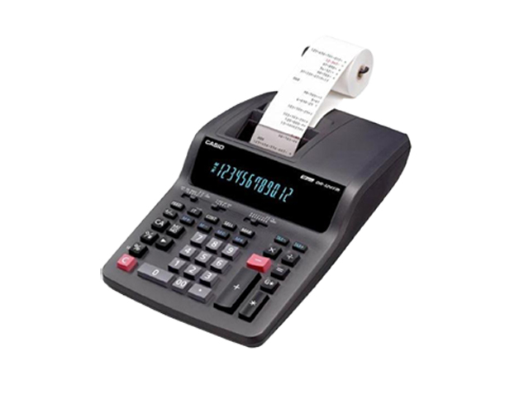

## Defining Our System

1. Power ON/OFF switch.
2. Dedicated MRC switch.
3. High speed operations.
4. Space given for printing receipts.
5. 14 digit display.
6. Operated on both solar as well as battery.
7. High level Maths and science functionality.
8. Multilevel display.

## SWOT ANALYSIS

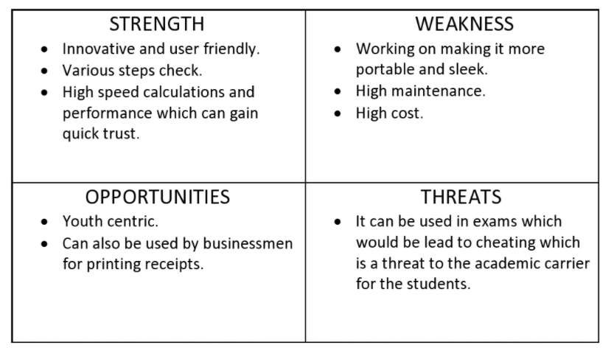

# 4W's and 1'H

## Who: **Student and businessman.**

What: **Smart Scientific Calculator**

When: **For fast and effective way to complete calculations.**

## Where: **Statics comparing the previous data with present data.**

How: **Easy to user interface.**

# Detail requirements

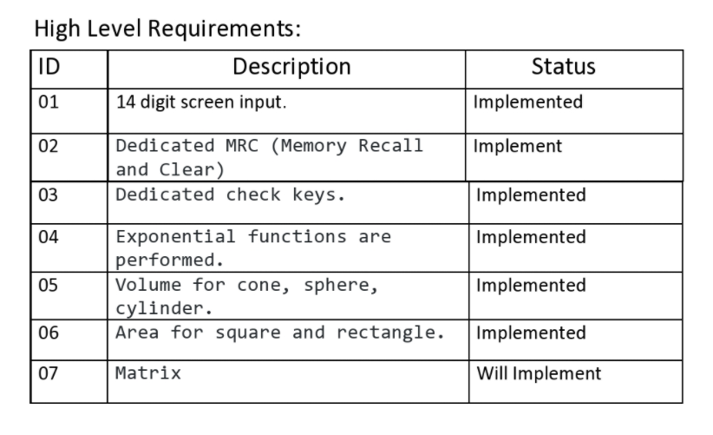

**Low Level Requirements:**